**Practical # 03**

# Building Blocks (Operators and Expression)

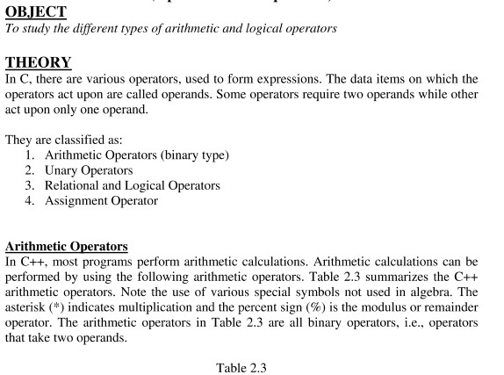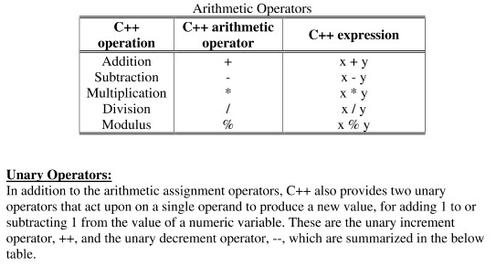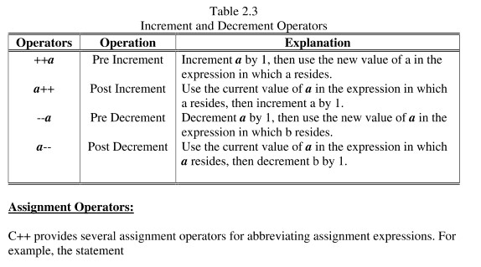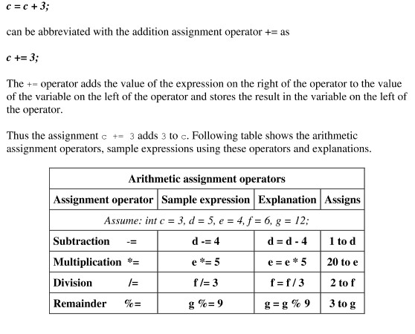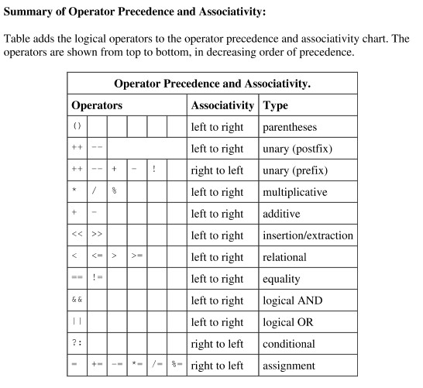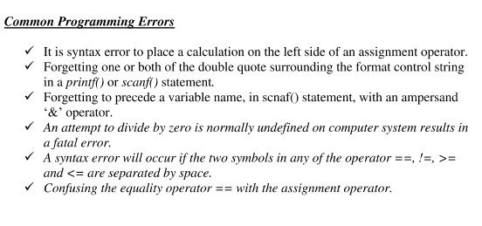

|  |
| --- |
| **#include<stdio.h> #include<conio.h> void main (void)**  **{ int a =10; int b =5; printf("%d + %d = %d\n", a,b,a+b); printf("\n%d - %d = %d\n", a,b,a-b); printf("\n%d * %d = %d\n", a,b,a*b); printf("\n%d / %d = %d\n", a,b,a/b); printf("\n%d \%% %d = %d\n", a,b,a%b); printf("\na = 10 and a++ = %d\n",a,a++); printf("\nb = 5 and ++b = %d\n",b,++b);**  **getch();**  **}** |

**Review Questions/ Exercise:**

**3.1)** Identify and correct the errors in the following statement .

1. if (c<7);

printf(“C is less than 7\n”);

Error: semi-colon after the if condition.

Correct: if (c<7) { printf(“C is less than 7\n”); }

1. if (c=>7);

printf(“C is equal to or less than 7\n”);

Error: => is incorrect use <= for less than or equal to.

Correct: if (c<=) { printf(“C is equal to or less than 7\n”); }

1. printf(“Remainder of %d divided by %d is \n”, x , y , x , % y);

Error: incorrect modulus operator placement.

Correct: printf(“Remainder of %d is divided by %d is %d\n”, x , y , x % y);

1. num1 + num2=ans;

Error: incorrect assignment operator use.

Correct: ans = num1 + num2;

**3.2)** a. Evaluate the following.

1. 9.0/6.0 + 5/2 = 4.0.
2. 9*3/4 = 6.75.
3. 14 % 7 + 3 % 4 = 3.

b. Determine the value assigned to the relevant variable

int a;

float b;

1. b = 5/4 ; b = 1
2. a = 5/4 ; a = 1
3. b = 5/2 + 3.0 ; b = 5.5

c. Determine the value of int x after each statement. Initially x = 5.

1. printf(“ %d\n”, x); ans: x = 5

printf(“ %d\n”, ++x); ans: x = 6

printf(“ %d\n”, x++); ans: x = 7

printf(“ %d\n”, x); ans: x = 7

1. printf(“ %d\n”, x); ans: x = 5

printf(“ %d\n”, --x); ans: x = 4

printf(“ %d\n”, x--); ans: x = 3

printf(“ %d\n”, x); ans: x = 3

**3.3)** State the order of evaluation of the operators in each of the following C statements and show the value of x after each statement is performed .

1. x = 7 + 3 * 6/2 – 1;
2. x = 2 % 2 + 2 -2/2;
3. x = ( 3 * 9 *( 3 + ( 9 * 3/ (3) ) ) );

**Answer:**

1. 15.
2. 1.
3. 324.

**3.4)** write a program that asks the user to enter two numbers, obtain the two numbers from the user and print the sum , difference, quotient and remainder of the two numbers.

#include <stdio.h>

int main() {

int num1, num2;

// Ask user for input

printf("Enter first number: ");

scanf("%d", &num1);

printf("Enter second number: ");

scanf("%d", &num2);

// Calculate and print results

printf("Sum: %d\n", num1 + num2);

printf("Difference: %d\n", num1 - num2);

printf("Quotient: %d\n", num1 / num2);

printf("Remainder: %d\n", num1 % num2);

return 0;

}

**Name: AREEBA _____**

**Roll #: 24AI10 _____**

**Date: 10\11\2024 _____**

**Subject Teacher / LAB Engineer**

**Remarks:**